Formal Design Proposal for the ENPH 253 2015 Robot Competition – “Fire at the SPCA!!”

Team 13 Members:

Wilhelm Friedrich Gavino (ID: 31789134)

Riley Harney (ID: 34643130)

James Hardolph Wasteneys (ID: 34140137)

Gregory Zhang (ID: 31007131)

Executive Summary

The purpose of this document is to propose a robot design for the ENPH 253 robot competition for the year of 2015. This proposal will be outlining major components of the robot such as the chassis design, driver and sensor systems, as well as code and algorithms. The proposal will also be outlining non-technical information, such as the strategy our team has chosen to approach for the competition, any risk management and contingency planning in the event of slight or major deviations from the team’s primary strategy, a list of agreed upon responsibilities and tasks divided amongst the four team members based on workload, as well as a list of major milestones that are to be completed along the course of the design and construction process.

The competition will be held on August 13, 2015, which will give the team roughly 2 months by the time this proposal has been written to design and construct the robot. In the event of a milestone that is in danger of not being met all members of the team are to take drastic measures in order to meet this milestone, which will include, but not limited to, emergency meetings during non-lecture times, extra lab hours before or after the lab time set by the timetable given permission by lab supervisors, and any minor arrangements in personal schedule in order to make time to conduct work. Due to the nature of each team member’s timetable most courses will be finished around the end of June. This would mean that more time can be allocated in completing the robot and its design starting from late June and early July, and milestones can be met at more reasonable times and can be spaced out much less in order to accommodate minor milestones shifts in the milestone schedule, all of which have been agreed upon by all four team members.

The initial size of the robot will be determined by the dimensions of the doorway the robot must pass through, which is an archway that is 14” wide with an opening whose maximum height is 18” and radius curvature of 8”. Additionally, the size will also be determined by a box provided by the course with similar dimensions. However, in order to meet the strategy set out by the team, the robot’s design will incorporate an extending arm that may exceed the dimensions stated earlier, which will be used in later portions of the course after the doorway.

Materials to be used when constructing the robot will mostly be provided by the ENPH 253 course. No components outside of materials provided by the course has yet to be implemented into the robot’s design. However, after the time of this proposal’s completion, if any changes to the design that require materials not provided by the ENPH 253 course, and agreed upon by all of the team’s members, happen to arise at some point during the design process, then procedures for requesting and procuring outside materials will be followed, which include purchasing materials not above the worth of $50.

Table of Contents

1. Preface 5

2. Overview of Basic Strategy 6

3. Chassis and Basket 7

3.1 Chassis Base 7

3.2 PCB Storage Box 8

3.3 Catapult Basket 9

3.4 Zipline 11

4. Drive and Actuator System 14

4.1 Drive System 14

4.2 Pet Retrieval Arm 16

5. Sensor System and Electrical Design 20

5.1 Sensors 20

5.1.1 Reflectance Sensors 20

5.1.2 Press-Button Sensors 20

5.1.3 Beacon-Detection Sensors 21

5.2 Circuits 21

5.3 TINAH Resources 22

6. Software Code and Algorithms 24

6.1 High-Level State Diagram 24

6.2 Tape Following Control Flow 25

6.3 Pet Retrieval Control Flow 26

6.4 Pet Launching Control Flow 27

6.5 IR Following Control Flow 27

6.6 Zipline Control Flow 28

6.7 Error Handling 28

7. Risk Assessment and Contingency Planning 30

8. Major Milestones, Task List, and Team Responsibilities 32

9. References and Appendices 33

Appendix A: Timeline 33

List of Figures and Tables

Figure 3-1: Preliminary Chassis Dimensions 7

Figure 3-2: PCB Storage Box 8

Figure 3-3: Catapult Basket (unfired) 9

Figure 3-5: Projectile Motion of Pets 10

Figure 3-6: Release Mechanism 11

Figure 3-7: Zipline 12

Figure 4-1: Free Body Diagram of Ramp Climb 14

Figure 4‑2: Pet Retrieval Mechanism 16

Figure 4‑3: Bottom Joint of Robotic Arm 17

Figure 4 ‑4: Top Joint of Robotic Arm 17

Figure 4‑5: Linkage in collapsed state 18

Figure 4‑6: Linkage in Extended State 18

Figure 5-1: Infrared Reflective Optosensor 20

Figure 5-2: Infrared Sensor Circuit 21

Figure 5-3: Zener H-Bridge Circuit 22

Table 5-1: TINAH Analog Input / Output Allocation 22

Table 5-2: TINAH Digital Input / Output Allocation 23

Figure 6-1: High-Level State Diagram 24

Figure 6-2: Tape Following Flowchart 25

Figure 6-3: Pet Retrieval Flowchart 26

Figure 6-4: Pet Launching Flowchart 27

Figure 6-5: IR Following Flowchart 27

Figure 6-6: Zipline Flowchart 28

Figure 6-7: Error Handling (Tape) Flowchart 28

Figure 6-8: Error Handling (IR) Flowchart 29

Table 7-1: Risk Assessment and Contingency Planning Table 30

Table 8-1: List of Major Responsibilities 32

# Preface

The following sections were authored by the four members of Team 13. The sections covered by each author are as follows:

**Wilhelm Friedrich Gavino** authored the following sections: the Executive Summary, the Preface, the Overview of Basic Summary, the Catapult Basket section, the Risk Assessment and Contingency Planning section, and the Major Milestones, Task List, and Team Responsibilities section. Wilhelm also authored the Letter of Transmittal.

**Riley Harney** authored the following sections: the Sensor and Electrical Design section.

**James Hardolph Wasteneys** authored the following sections: the Pet Retrieval Arm section.

**Gregory Zhang** authored the following sections: the Chassis section, the Drive System section, and the Software Code and Algorithms section. Gregory also created the timeline for the project outlined in Appendix A, and edited the Overview of Basic Strategy.

We certify that the work covered in this document is a product of our own ideas and research, with no major discussion related to the contents of this document with any other team whatsoever. In doing so, we claim all responsibility for any consequence, whether positive or negative, that may arise due to the production of this document.

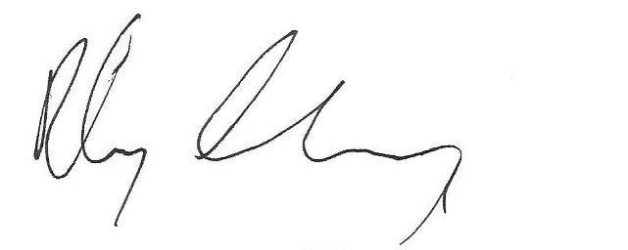

Wilhelm Friedrich Gavino Riley Harney

(ID: 31789134) (ID: 34643130)

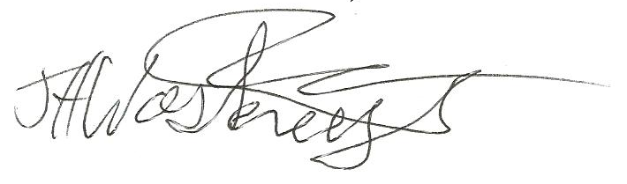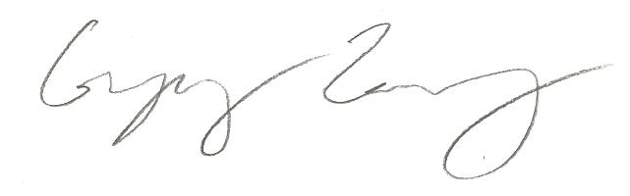

James Hardolph Wasteneys Gregory Zhang

(ID: 34140137) (ID: 31007131)

# Overview of Basic Strategy

The strategy our team will be approaching given the circumstances of the competition is as follows:

The robot will be using a tape following mechanism that uses a QRD1114 Infrared Reflective Optosensor in order to follow the path set out for the course. It will also be using these optosensors to detect tape markings that represent the location of a pet. The first three pets are located to the side of the path, directly beside the tape markings. Our robot will utilize an arm located directly above the optosensors in order to retrieve the pet. The arm is equipped with a piece of steel, which will be used to pick up the pet by the magnet on its head. A switch in the arm next to the steel piece will tell the robot to raise the arm and release the pet into a basket carried by the robot.

The basket itself is designed as two separate parts, essentially two baskets on top of one another. The first basket will be designed to carry the first three pets. After climbing the ramp, the robot will proceed to launch the first three pets towards the start/rescue area, which is located next to the top of the ramp and a level below, by using the first basket as a catapult. This would also, in turn, expose the second basket for the last three pets, with the first basket remaining attached and acting as a wall for the second basket.

At this point the operation of pet retrieval will be changed in order to accommodate each of the special cases of the last three pets. The fourth pet is located on the path in front of the robot, and marked with tape markings. Thus, once the robot locates the tape marking, as it did with the first three pets, it will attempt to grab the pet by reaching out in front rather than from the side. The pet will be carried on the second basket now exposed after the ejection of the first basket earlier. The fifth pet is not marked with tape markings, but it is at a known distance from the end of the tape. The robot will use wheel encoders to let it know when it has traveled the right distance to pick up the pet, and then raise the arm to the correct location and search a larger area than for the other pets (to account for the greater error involved).

After retrieving the fifth pet, the robot will use a QSD124 phototransistor backed by a filtering and amplifying circuit to detect the IR rescue beacon and locate the sixth pet buried in rubble made of soft foam. Once it reaches the container with the pet and rubble the robot will use sweeping motions in order to clear the rubble and locate the pet. Once the switch in the arm detects that a pet is grabbed the robot will proceed to release the pet onto the basket.

The robot should now be located under the zipline. The basket will be raised and will grab the zipline automatically with rollers mounted on bearings, separating it from the robot. The basket will travel down the zipline, either powered with a separate motor or not depending on materials available and tests that will be conducted later.

# Chassis and Basket

## 3.1 Chassis Base

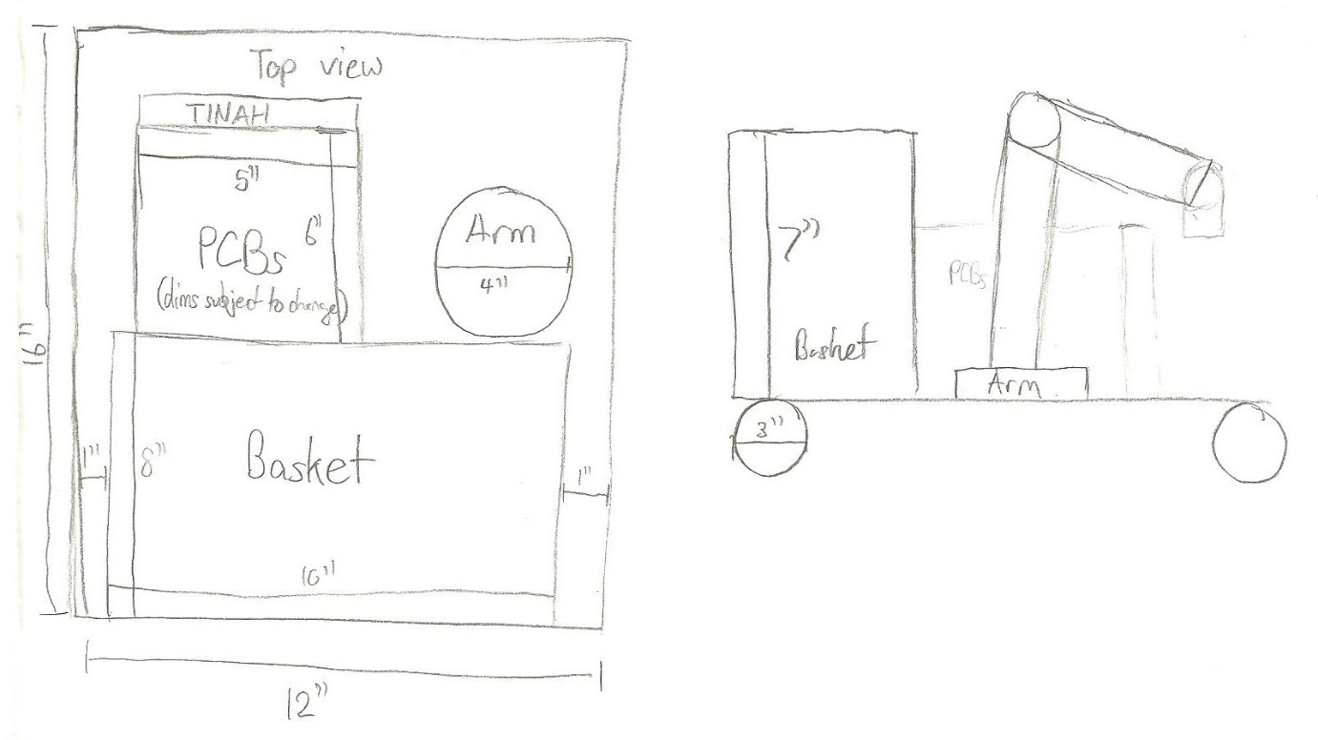

Figure 3-1: Preliminary Chassis Dimensions

The base of the robot will be a simple, symmetrical design. It will be made out of a flat piece of wood in order to reduce weight and the risk of electrical shorts through the body of the robot.

## 3.2 PCB Storage Box

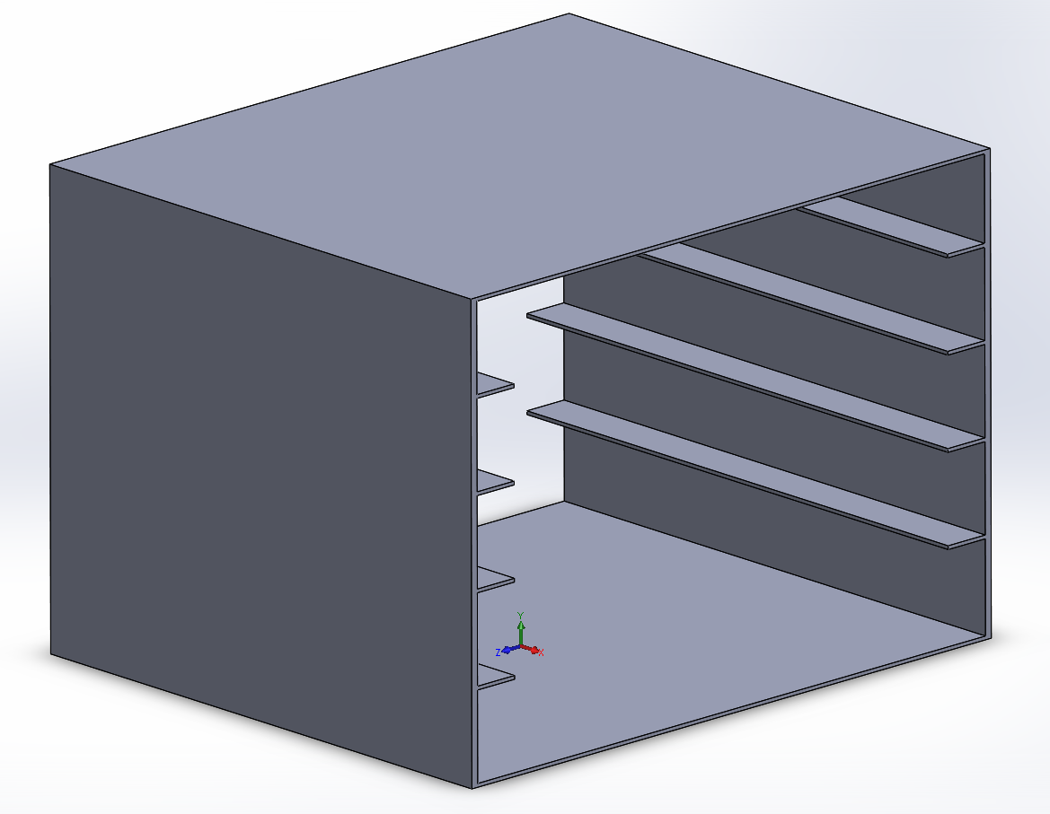

Figure 3-2: PCB Storage Box

The large PCBs will be stored in a circuit tray (which will be mounted on its side). This tray will be in the middle of the robot, most likely under the arm (which will be supported separately). It will be made out of a nonconductive material such as plastic or wood. The TINAH board will be in spare space at the front of the robot, and will be placed so that it is easily accessible (on top).

## 3.3 Catapult Basket

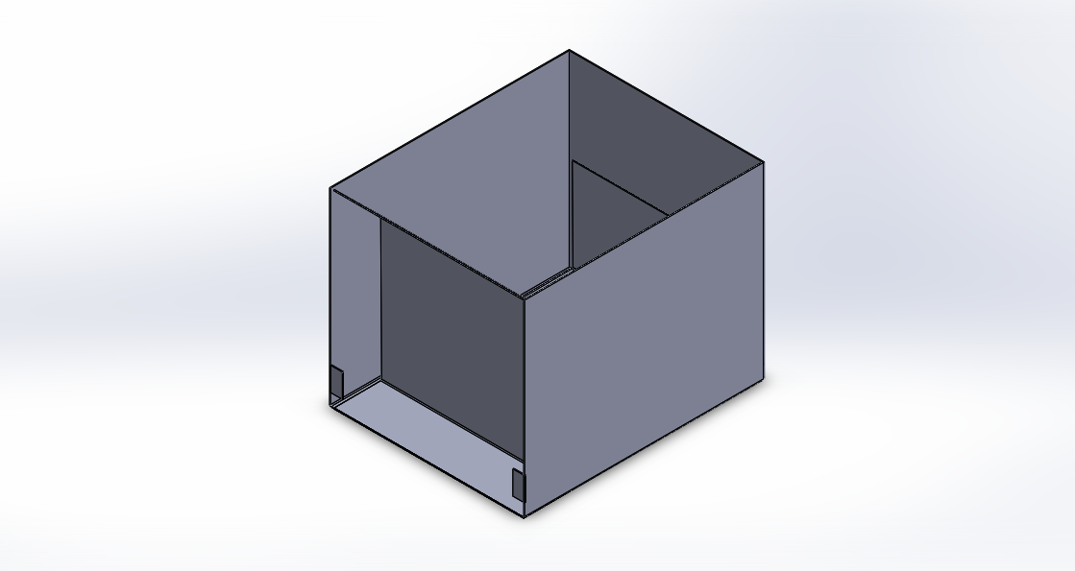

Figure 3-3: Catapult Basket (unfired)

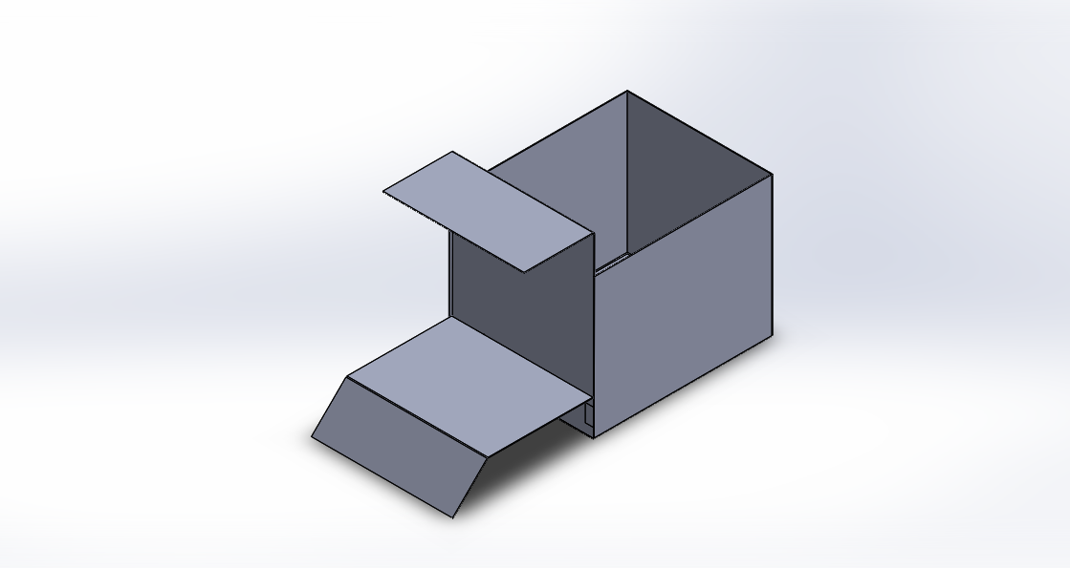

*Figure 3-4: Catapult Basket (fired)*

The above figures show isometric views of the robot’s catapult basket in its two different states: unfired and fired. The basket unfired length, width, and height are 8”, 10”, and 7” respectively. The 10” width will travel parallel to the width of the robot, in order to fire the first three pets off the side of the ramp and into the start area. The basket’s maximum length, width, and height after it is fired would be 8”, 18”, and 10” respectively.

The catapult is fired using 2 torsion springs, one on each end of the basket’s length. Using the figure below we may find the minimum spring constant of the torsion spring as a function of the distance needed to travel to reach start area. Please note that the pets were idealized as cylinders of 6” height and 4” diameter during these calculations.

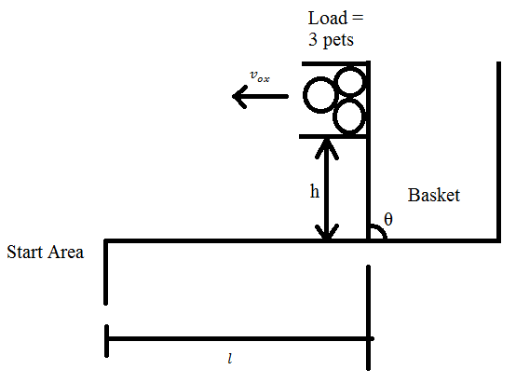

Figure 3-5: Projectile Motion of Pets

Relevant Equations:

Conservation of Energy shows:

Rearranging the terms, and given that when the basket is fired, we find the minimum required spring constant of one torsion spring as a function of :

The known constants are:

The release mechanism involves a pin attached to a pull solenoid holding the catapult down, and passing through a hole through the basket and the catapult. Once the catapult is required to fire, the solenoid pulls the pin and the torsion springs retract and fires the catapult.

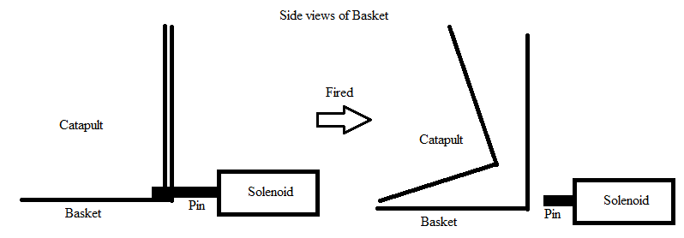

Figure 3-6: Release Mechanism

## 3.4 Zipline

The basket will separate from the main body of the robot and go down the zipline individually. In order to do this, the basket will be raised until the clip-on supports are pushed against the zipline. (These supports will cover about 8 inches horizontally, which is more than enough to deal with the 5 inches the zipline will move sideways in the 6 inches of length of our basket: the tendency for the zipline to move toward the center creates room for geometric error.) As the zipline is pressed against the supports, they will bend backwards until the zipline moves between them, and then spring back into place. (The supports will have a default position determined by the actual shape of the supporting blocks.) The springs will hold the supports so that when the basket raising mechanism is lowered, the zipline cannot fall through the supports. Finally, since the supports are mounted on bearings (low friction), the downward slope of the zipline (as well as the comparatively light weight of the basket, which stops the zipline from bending significantly) will cause the basket to be carried into the safe zone by gravity.

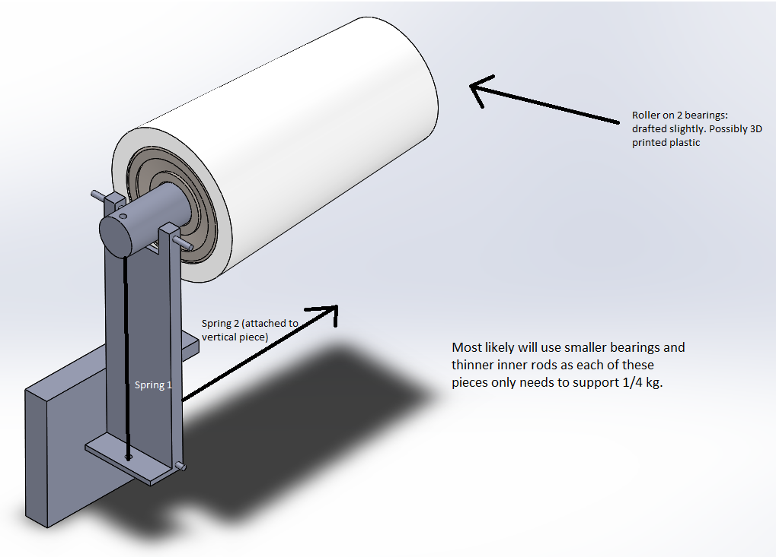Figure 3-7: Zipline

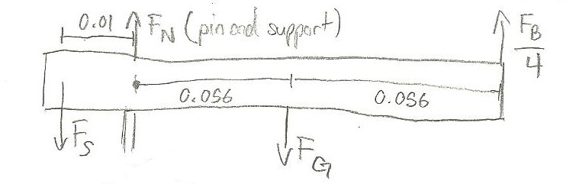Figure 3-8: Zipline Free-Body Diagram

Estimate (a worst-case scenario estimate):

Estimate :

Taking moments about the rotation pin and assuming that the moment from FN = 0 (very short perpendicular distance):

When the basket is on, the spring actually doesn’t have to pull at all. The force will go into the support and then pin instead, of the order of about 100 N. Given aluminum’s yield strength of 43 MPa, the area has to be less than 0.24 mm2 to cause problems: in the current model the area of contact is over 10 mm2.

Now assuming that (for the case where the zipline is not yet on the basket):

This indicates that the spring needs to apply at least 11 N of force to lift the zipline roller: 30 N is probably advisable in order to allow the mechanism to spring back into place quickly: since the spring can be easily changed we don’t go deeply into this calculation here.

The force on the second spring doesn’t need to be very large to counteract rotation when the basket is on the zipline, as the perpendicular distance from the spring to the lower rotation axis is much larger than the distance for the normal force applied by the rod. Since this normal force is on the order of 100 N, we can estimate that the minimum required force for the second spring is about 20 to 30 N, although higher forces will allow the mechanism to spring back faster.

It is also important that the springs not be too strong, or the lifting mechanism will not be able to push the supports through the zipline. This will be more easily tuned using real springs once the assembly is built, but the forces seem to be small enough to be manageable with a DC motor.

# Drive and Actuator System

## 4.1 Drive System

The robot will be relying on either three wheels in a triangle formation or four wheels for driving and steering. Two rear wheels will be responsible for driving the robot (with Barber-Colman geared motors), using differential steering. Aside from being a free spinning support for the front side of the robot the front pivot wheel (or wheels) will also follow the tape, as it is the rough location of the QRD1114 sensors used for the sensor system.

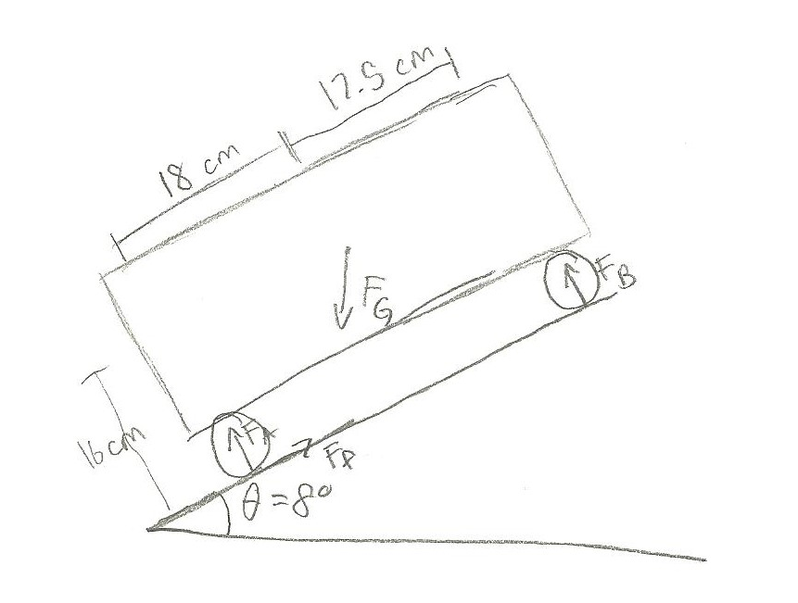

Figure 4-1: Free Body Diagram of Ramp Climb

The speed required was calculated using an estimated distance that needs to be travelled by the robot throughout the whole competition (i.e. distance of the taped and untaped portion), where this distance was equal to about 8 m. The angular velocity of the wheels here is:

The torque required was calculated based on the ramp, as this is the most difficult part of the competition for the wheels. The following assumptions were made (as worst-case scenarios):

Given these assumptions a free-body diagram and the equations of motion are outlined below:

This acceleration implies that the robot will be able to get up the ramp given sufficient torque.

If we assume that a=0, the absolute minimum force required is 13.6N: we double this to about 27N to provide a factor of safety. We now have a system of equations (where is the gear ratio):

(This last equation comes from assuming that torque and angular velocity of the motors are linearly related.)

We arbitrarily choose the radius of our wheels to be 3 cm: we want the torque going up the ramp to be 0.1 N-m (for maximum power), and this yields .

Since we are overstating the weight of the robot and the force required to get up the ramp, the robot is likely to be able to go faster than this (and it will certainly go faster along flats).

The max power required is .

## 4.2 Pet Retrieval Arm

The robots propulsion system consist of two DC motors powering the rear wheels independently. Steering will be done through differential power distribution to the rear wheels. The front wheels will move freely and in any direction.

Pet retrieval will be done through a large articulated arm. In order to retrieve pets in many different situations the arm will need at least three degrees of freedom.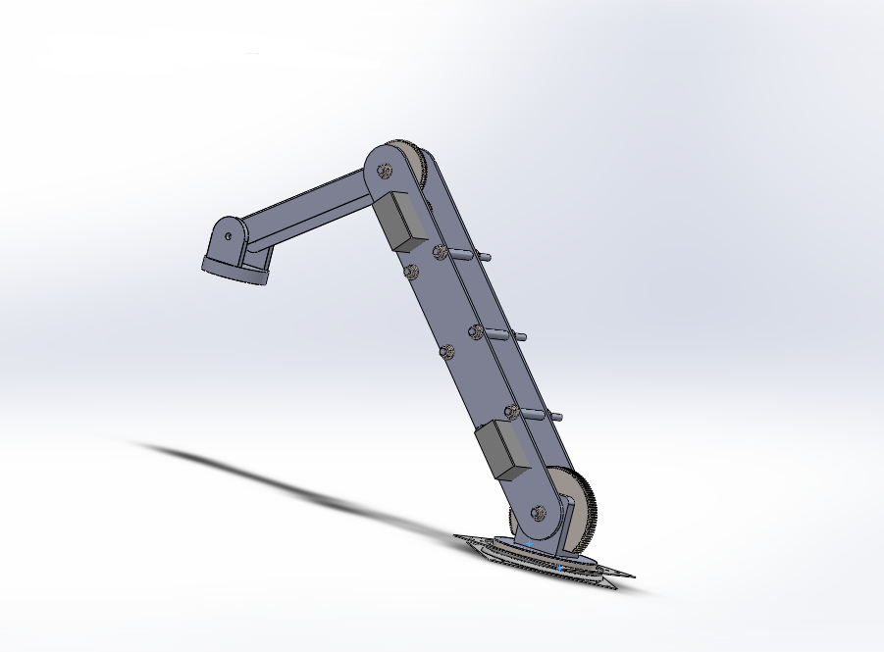

Figure 4‑2: Pet Retrieval Mechanism

To achieve this the robot will sit on a rotating turntable. The turntable will be made with a “Lazy Susan” bearing attached to the chassis with an internal spur gear driven by a stepper motor. The stepper motor will allow the arm to rotate a greater range than an RC servo would allow, and will simplify the design compared to a DC motor and potentiometer combination. First section of the arm will rotate around a large spur gear fixed to the mounting bracket. The rotation will be driven by an RC servo geared down to approximately a 4:1 ratio.

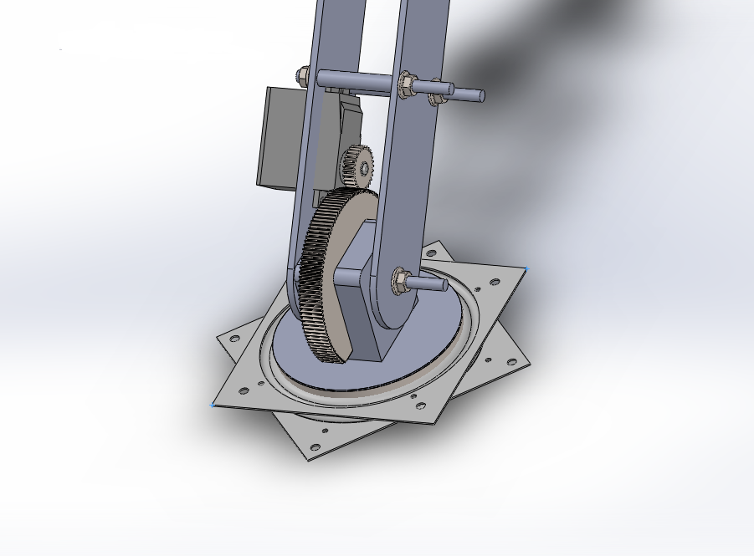

Figure 4‑3: Bottom Joint of Robotic Arm

The second segment of the arm will be attached to a large fixed gear and driven by another RC servo mounted on the first arm segment. 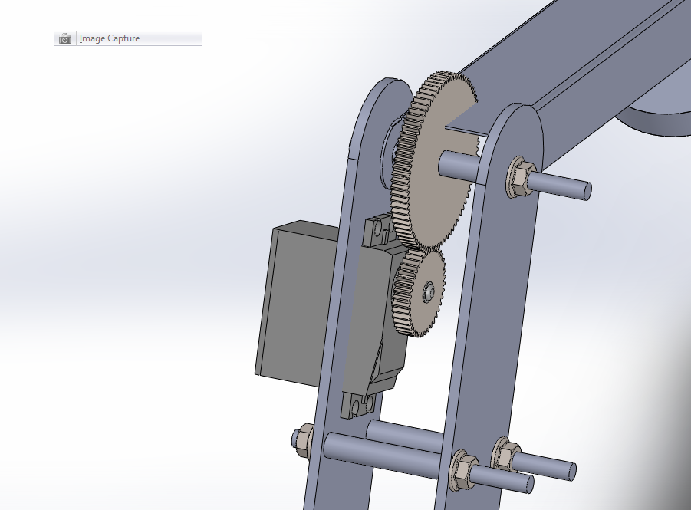

Figure 4 ‑4: Top Joint of Robotic Arm

The final segment of the arm will hang freely and contain the mechanism needed to pick up the pets. This will be done either with an electromagnet or a ferrous plate and release mechanism. Major design considerations for this arm are the length of the arm segments and the gear ratio needed in order to move the arm.

Another key actuator system for the robot is the basket lift mechanism. The purpose of the lift mechanism is to lift the pet basket into position to engage the zipline. In order to do this the robot will use an accordion linkage. The linkage will be driven by an electric motor in a rack and pinion configuration. The basic outline can be observed in the following figures.

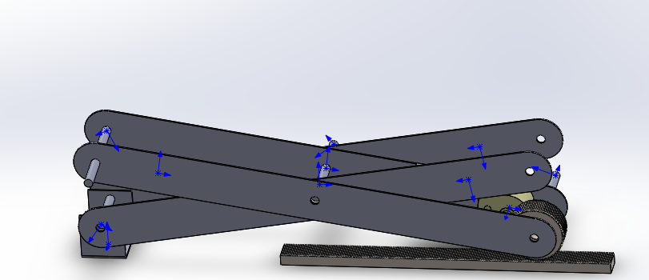

Figure 4‑5: Linkage in collapsed state

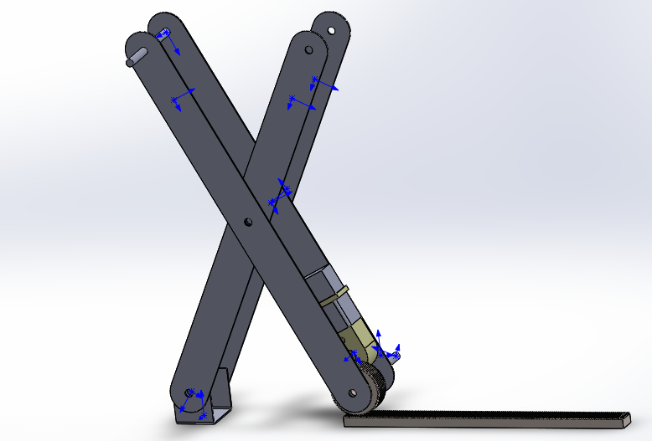

Figure 4‑6: Linkage in Extended State

The top of the linkage will support the bottom of the pet basket so that it won’t slide off sideways but when it engages the zipline it can slide off vertically. A very important design consideration for this system is whether the DC motor will have enough torque to extend the linkage from its collapsed position. Because of the geometry of the problem, the torque required will be maximized in this collapsed state. In order to combat this, springs could be placed horizontally at either the top or the bottom of the linkage. These springs would provide enough force to allow the motor to drive the linkage at its weakest point, but not enough to cause the linkage to prematurely extend.

# Sensor System and Electrical Design

The main focus is to maintain simplicity. To achieve this, the electrical system consists of several compact, modular, and easily accessible PCBs and sensors. This system of PCBs will be mounted onto the front section of the robot chassis. It will enclosed by an aluminum sheet-metal box, protected with an inner layer of HDPE plastic.

## 5.1 Sensors

### 5.1.1 Reflectance Sensors

There will be 6 QRD1114 Infrared Reflective Optosensors. Two sensors are to be used as wheel encoders, mounted by the rear driving wheels. For tape following, two parallel, downward facing sensors will be securely mounted under the front section of the chassis. The remaining two sensors will also be mounted under the chassis, but located on the left and right side to detect pet location tape markings.

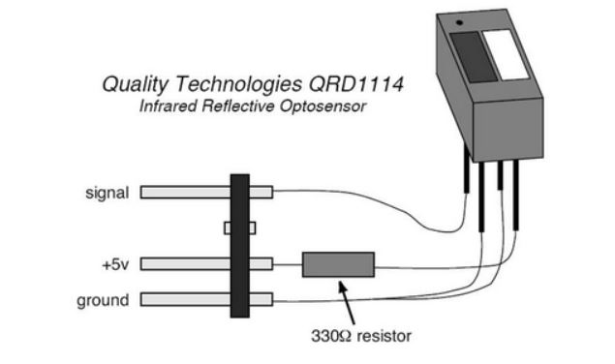

Figure 5-1: Infrared Reflective Optosensor

### 5.1.2 Press-Button Sensors

There will be six microswitch sensors. Three are to be mounted at the front of the chassis, one centered and two on each side. They will extend past any extruding part of the robot, and be used for collision detection. One sensor will be mounted on the arm, to detect the presence of an attached pet. The remaining two sensors will be used to detect the single occurring processes of the robot; the zip-line mechanism and the catapult release.

### 5.1.3 Beacon-Detection Sensors

Two infrared sensors (QRD124 Phototransistors) will be securely mounted in an outward facing position on the front of the chassis. They will be used to locate the beacons.

## 5.2 Circuits

1 x Central PCB Hub (Power (+15/+9/-9), Ground, TINAH inputs/outputs)

This PCB acts as a central hub for all subsequent circuits, power sources and TINAH inputs/outputs. The only dedicated rails will be +15V, +9V, -9V, Ground, two IR Sensor Circuit TINAH inputs, and 3 Zener H-Bridge TINAH outputs. The board will have extra rails with female header pins, to accommodate other TINAH inputs/outputs and any future modifications.

2 x IR Sensor Circuit

There will be two Infrared Sensor Circuits, each built on separate PCBs. They will be connected to the +9V/-9V/Ground rails from the central hub.

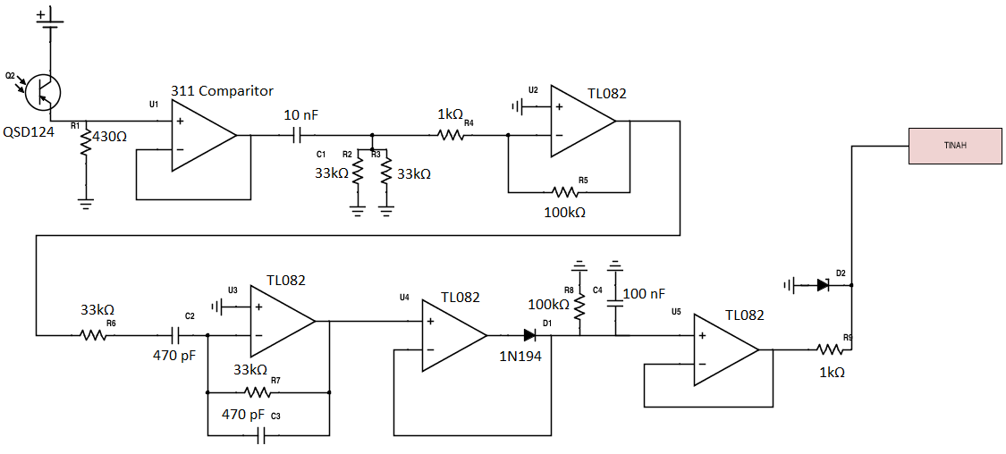

Figure 5-2: Infrared Sensor Circuit

3 x Zener H - Bridge Circuit

Three Zener H-Bridge PCBs will be constructed to drive the two Barber-Colman geared motors and zip-line lift apparatus. They will be connected to the -15V/Ground rails from the central hub.

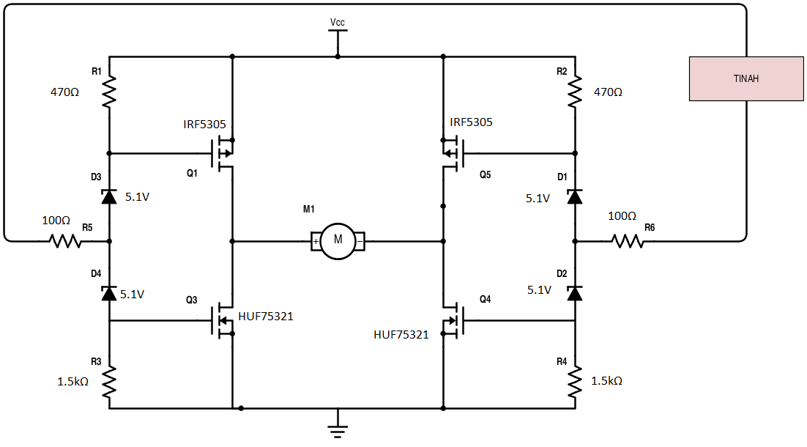

Figure 5-3: Zener H-Bridge Circuit

## 5.3 TINAH Resources

Table 5-1: TINAH Analog Input / Output Allocation

|  |  |
| --- | --- |
| TINAH Analog Pin Number | Device |
| 0 | Left Wheel Encoder Sensor |
| 1 | Right Wheel Encoder Sensor |
| 2 | Left Tape (Follow) Sensor |
| 3 | Right Tape (Follow) Sensor |
| 4 | Left Tape (Pet Marking) Sensor |
| 5 | Right Tape (Pet Marking) Sensor |
| 6 | Left IR Sensor |
| 7 | Right IR Sensor |

Table 5-2: TINAH Digital Input / Output Allocation

|  |  |
| --- | --- |
| TINAH Digital Pin Number | Device |
| 0 | Pet Pickup Button |
| 1 | Zip-line Mechanism Release Button |
| 2 | Catapult Release Button |
| 3 | Left Collision Button |
| 4 | Centeral Collision Button |
| 5 | Right Collision Button |

# Software Code and Algorithms

Our strategy for the software design is to make it modular, tracking the current state of the robot (including parameters like pets retrieved and approximate location on the track) in order to aid in decision-making.

6.1 High-Level State Diagram 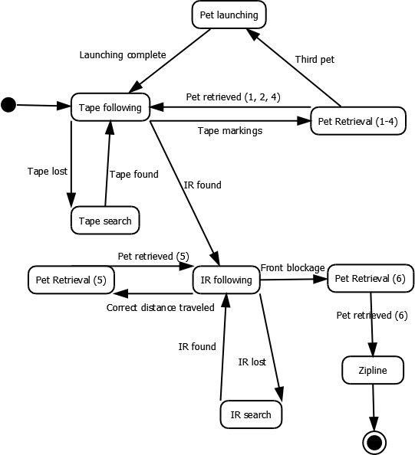

Figure 6-1: High-Level State Diagram

The three most important stages of the flow are the tape following, IR following, and ziplining (with pet retrieval interspersed). Each of the individual states is documented below.

6.2 Tape Following Control Flow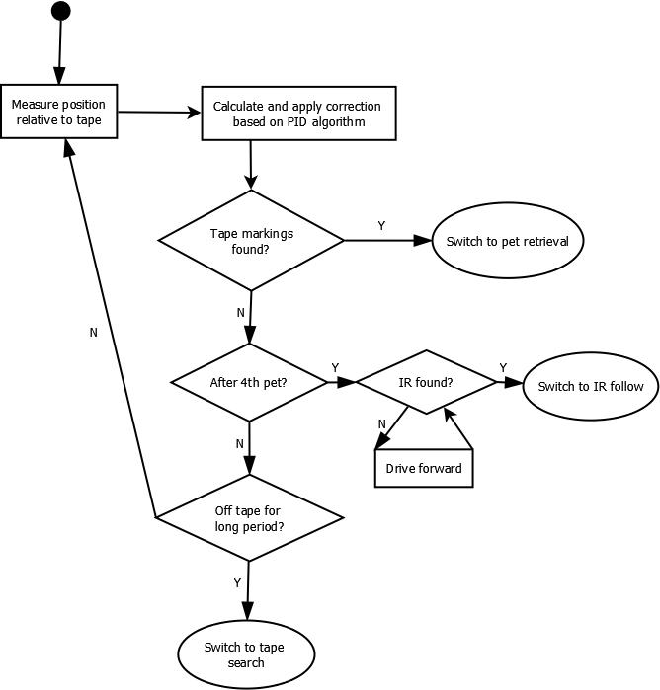

Figure 6-2: Tape Following Flowchart

Tape following will be handled using the PID control algorithm described in class: this is not actually shown in the flowchart, but is wrapped into the correction calculation step. The robot will check for tape markings often (as often as required to always catch them after testing): it will check for IR and tape less often in order to make the algorithm run faster.

## 6.3 Pet Retrieval Control Flow

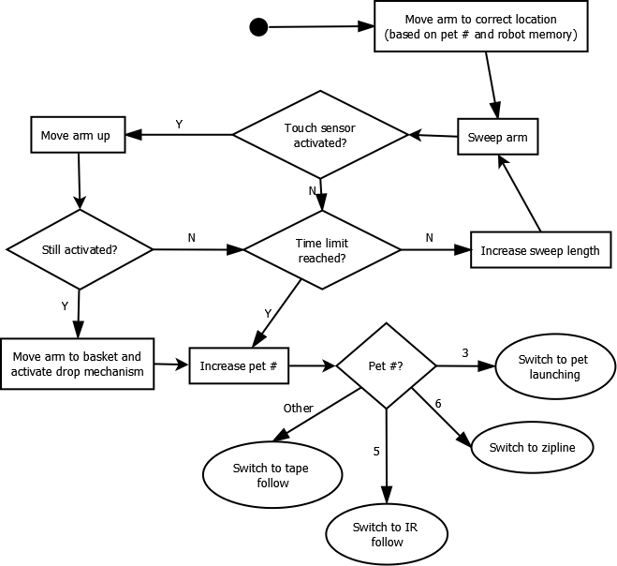

Figure 6-3: Pet Retrieval Flowchart

For the first step, the correct location of the arm for each pet will be hardcoded, and then the robot will search around this location using arm sweeps. If the pet isn't caught after each sweep, the robot will continue sweeping (in larger and larger areas) until a time limit (TBD) is reached, in which case the robot will just skip the pet. The robot will also make sure that any sensor activations aren't spurious, especially in the case of the pet covered in foam, by lifting the arm and rechecking the sensor. An important factor is the tracking of how many of the pets have been picked up: this number may be modified (since the robot may miss a pet altogether) by the robot's knowledge of its location on the course, and of the differing characteristics of each pet.

## 6.4 Pet Launching Control Flow

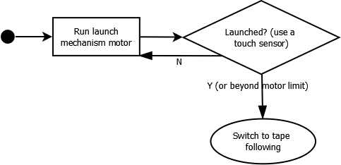

Figure 6-4: Pet Launching Flowchart

Pet launching is intended to be as simple as possible: the launch mechanism motor will simply run until it detects that launching has occurred (or that it has run more than a hardcoded limit, in which case it will assume launching has occurred).

## 6.5 IR Following Control Flow

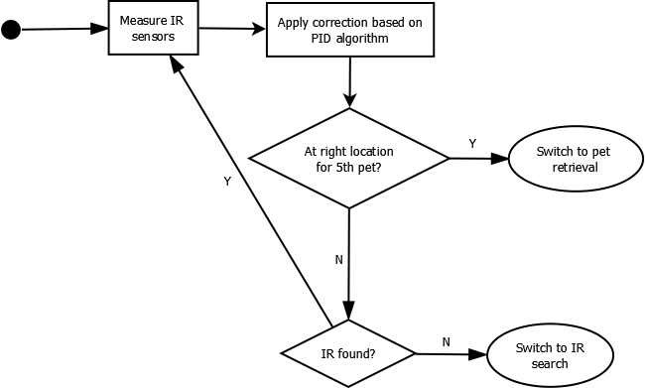

Figure 6-5: IR Following Flowchart

The IR algorithm is fairly similar to the Tape following algorithm, with the key difference that the inputs are analog instead of digital: this simplifies the algorithm somewhat as keeping track of the derivative is simplified with a more-or-less continuous function. In this case, the error function is based on the difference of the values between the IR sensors.

## 6.6 Zipline Control Flow

C:\Users\Gregory\Documents\GitHub\enph253-2015-team13\Robot\State Diagrams\Zipline State Diagram.png

Figure 6-6: Zipline Flowchart

Ziplining is fairly simple, as there is no need to control a zipline arm: the basket will clip itself onto the zipline as it is lifted. The robot simply fully lifts the accordion flexure and then lowers it again.

## 6.7 Error Handling

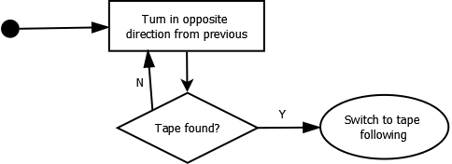

Figure 6-7: Error Handling (Tape) Flowchart

If the robot hasn't found tape for a while, it will guess that it missed a crossing of the tape and will turn in the opposite direction that it was turning in at a slow speed until it finds tape again. In order to avoid this problem altogether, proportional gain will be prioritized over speed so that the robot corrects itself quickly (as the robot doesn't need to be very fast).

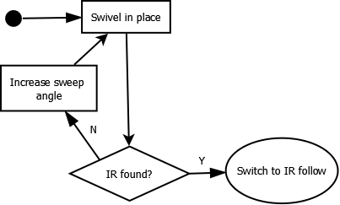

Figure 6-8: Error Handling (IR) Flowchart

If the robot loses the IR signal, it will make successively larger sweeps in place until it finds IR.

# Risk Assessment and Contingency Planning

The following lists the various risks that may occur during the major processes of this project and what our team plans to do in response to the risk, as well as the date as to when these responses must occur. The dates give rough estimates depending on the impact the risk may have on the overall project, and how it fits in the timeline of the project.

Table 7-1: Risk Assessment and Contingency Planning Table

|  |  |  |  |  |
| --- | --- | --- | --- | --- |
| Risk Condition | Probability of occurrence | Impact to Project | Change to Work Plan | Expected Date of Risk Decision |
| Arm Risks | | | | |
| Arm cannot correctly identify positions | Medium | Pet retrieval becomes a major issue, preventing our robot from scoring points. Recalibration of the arm's potentiometers would be required. | Recalibrate the potentiometer/s used on the robotic arm so that it utilizes the correct angles that allows for effective pet retrieval. Recalibrating components such as wheel encoders and QRD sensors may also be required to identify positions. | Two weeks before time trial |
| Arm cannot locate pets (either due to the arm being too long or short) | Medium | Pet retrieval becomes a major issue, preventing our robot from scoring points. A redesign to the arm and/or its placement must be conducted. | Redesign the arm with different dimensions in order to reach a wider area. Another option is to change the placement of the arm on the chassis. | Two weeks before time trial |
| Arm is distorting performance of tape following sensor (since it is placed close to the sensors) | High | Tape following system becomes flawed due to extra mass on top of the sensors (pivot of the robot). | Recalibration of the tape following system will most likely be conducted. Another option would be to change the placement of the arm so that it does not significantly distort the performance of the tape follower. | Week of July 13, 2015 |
| Basket Risks | | | | |
| Basket catapult is unable to launch three pets into the rescue area | Medium | Affects strategy of guaranteeing at least three points when scoring. This will either require different torsion springs must be used, or a redesign of the release mechanism depending on the situation. | If the issue is a result of the torsion springs not being strong enough to catapult the pets into rescue area, then the torsion springs need only be replaced by stronger ones (a redesign of the basket may be required to accommodate larger springs). The more likely scenario would be that the release mechanism does not activate properly, which would require a redesign of the whole mechanism. | Week of July 13, 2015 |
| Basket is unable to locate and grab the zipline | High | Accordion linkage does not allow the basket to rise up in order to grab the zipline, or the motor is too weak to lengthen the linkage. All of these issues would likely be due to friction. Grabbing the zipline, however, would require a redesign of the grabbing mechanism. | Rather than an accordion linkage, the basket would utilize a pulley system to rise up in order to grab the zipline. | Week of July 6, 2015 |
| Basket is unable to separate from the robot once attached to the zipline | Low | It affects the delivery of the last three pets if the basket gets stuck on the surface attached to the linkage. | A redesign of the accordion linkage's surface where the basket will sit on will be required to minimize the chances of the basket getting stuck. | Week of July 13, 2015 |
| Driver System Risks | | | | |
| Driver System's optimal speed is too slow to be considered a competitive speed and/or carry the robot over the ramp | High | The drive system would need to be recalibrated, which would require additional time. | Different sizes of drive gears and or wheels may need to be fabricated in order to change the power output of the motors. Other options include changing the power input into the motor, or using different motors for the drive system altogether. | Week of July 13, 2015 |
| Size of gears are unrealistic in terms of the amount of space claim available for the gears. | Medium | Depending on the gear calculations, some gears may be too big to realistically or effectively fit in the robot. | Recalculation of the gear calculations must be conducted, taking into account any newly found constraints of the robot's space claim. | Week of June 29, 2015 |
| Sensor System, Tape Follower, Electrical Circuit Risks | | | | |
| Tape Follower loses sight of the tape, especially when making turns at corners | High | Affects the overall strategy for the competition if the robot is unable to effectively follow the tape. Many calibration tests would be required. | Many calibration tests must be conducted on the robot with most, if not all, of its components installed. This would be time consuming but essential, so the assigned team member who will be conducting these tests will be occupied for the duration of the tests. | Tests should start on the week of June 29, 2015 |
| Sensor System is unable to operate over the 1-7 foot range when locating the final pet | High | The robot would be unable to detect the IR beam, which locates the final pet, as well as the zipline. | The IR detection circuit must be redesigned in order to accommodate a wider range. | Week of June 29, 2015 |
| Construction Risks | | | | |
| Accordion linkage is not built reasonably straight, and may have additional friction due to dissimilar lengths of links | Medium | Refabrication of links would be required in order to fabricate a more effective accordion linkage. | Accordion links must have the same lengths and riveted in the exact same places. The accuracy of this process is crucial for the effectiveness of the linkage, seeing as that it determines the delivery of the last three pets. | Week of June 29, 2015 |

# Major Milestones, Task List, and Team Responsibilities

Major milestones that must be met before Major Milestone Day include:

* Preliminary chassis, driver system and sensor system construction must be complete in order to start tape following/optimal speed tests
* Work on arm design and construction must be started

A detailed list of major tasks is as follows:

1. Design, construction, individual testing, and redesigning of major components
   1. Chassis – space claim tests to be conducted once all internal components are constructed
   2. Arm – must be tested for pet retrieval and deposit
   3. Driver system – overall must be tested for optimal speed when following tape on flat and ramped surfaces
      1. Wheels
      2. Motors and Gears
   4. Electrical system and code design
      1. Sensor and tape follower circuits – must be able to follow tape, and detect IR at the distances dictated by the course and team strategy
      2. Component communication circuit and codes/algorithms – code must be tested for effective inter-component communication
   5. Basket – catapult mechanism must be able to consistently launch pets into rescue area, as well as be able to reach the zipline when it is raised
2. Integration of components/Overall assembly
   1. Connection of two or more components, and performance testing
3. Overall system performance testing and redesigning based on results and time trial

Table 8-1: List of Major Responsibilities

|  |  |
| --- | --- |
| Team Member | Major Responsibilities |
| Wilhelm Gavino | * Chassis Construction and Testing * Driver System Construction/Integration and Testing * Basket System Design, Construction and Testing |
| Riley Harney | * Sensor System Design and Testing * Electrical System Design and Testing |
| James Wasteneys | * Chassis and Basket Design * Driver System Design * Arm Design, Construction and Testing |
| Gregory Zhang | * Code/Algorithm Design, and Resdesign |
| Shared | * Code Debugger and System Performance Testing * Must be able to cover or aid another team member with his assigned responsibility if help is required * Minor component and circuit board construction |

# References and Appendices

## Appendix A: Timeline

|  |  |  |
| --- | --- | --- |
| Week | End Date | Expected Milestones |
| 7 | June 26 | Plan and build circuits, finish Solidworks models |
| 8 | July 3 | Finish building circuits, start work on basket |
| 9 | July 10 | Finished basket and catapult, start work on arm and related code, chassis/drive mechanism and related code |
| 10 | July 17 | Complete chassis components and drive mechanism: robot should drive and follow tape/IR, as well as switch between modes. Arm should be mostly complete, code should be complete. Finish and test zipline attachment pieces. |
| 11 | July 24 | TIME TRIALS: robot should follow tape and IR with arm attached (although not necessarily operational). Finish arm and related code. Work on lift mechanism for basket. By the end of this week the robot should run through the entire course. |
| 12 | July 31 | Testing/tuning |
| 13 | August 6 | Testing/tuning |